Lesson 5

Similar Triangles and Indirect Measurement

Indirect measurement allows you to use properties of similar polygons to find distances or lengths that are difficult to measure directly. Angle-Angle (AA) Similarity – If two angles of one triangle are congruent to two angles of another triangle, then the triangles are similar.

Example
LIGHTING Tyrone is standing next to a light pole in the middle
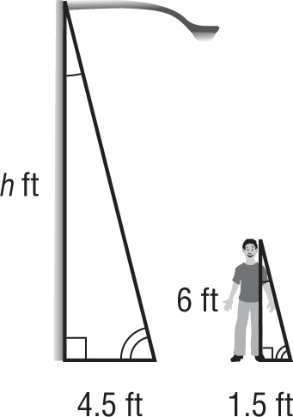
of the day. Tyrone’s shadow is 1.5 feet long, and the light
pole’s shadow is 4.5 feet long. If Tyrone is 6 feet tall, how
tall is the light pole?

Write a proportion and solve.
← Tyrone’s height light
← light pole’s height

Tyrone’s shadow →
light pole’s shadow →
$\frac{1.5}{4.5 } = \frac{6}{h}$

1.5 • h = 4.5 • 6 Find the cross products.
1.5h = 27 Multiply.
$\frac{1.5h}{1.5}$ $= \frac{27}{1.5}$ Division Property of Equality
h = 18 Simplify.
The light pole is 18 feet tall.

Video – Follow Along
SURVEYING – The two triangles shown in the figure are similar. Write and solve a proportion to find the distance (d) across the river.

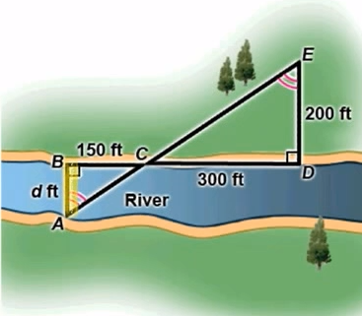

Exercises
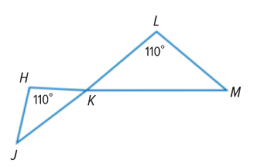
- Determine whether the triangles are similar. If so, write a similarity statement.

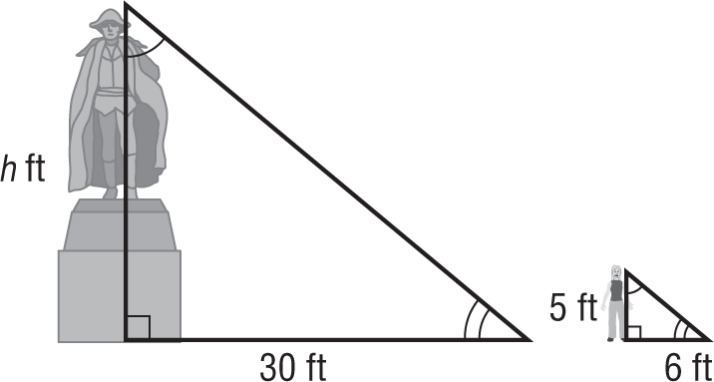
2. MONUMENTS A statue casts a shadow 30 feet long. At the same time, a person who is 5 feet tall casts a shadow that is 6 feet long. How tall is the statue?

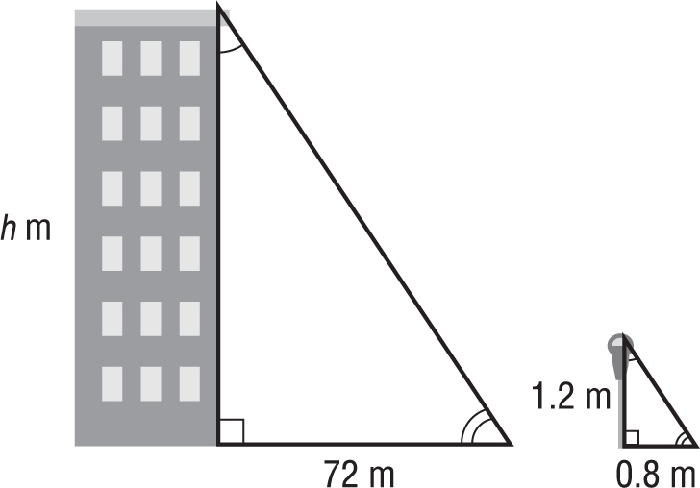
3. BUILDINGS A building casts a shadow 72 meters long. At the same time, a parking meter that is 1.2 meters tall casts a shadow that is 0.8 meter long. How tall is the building?

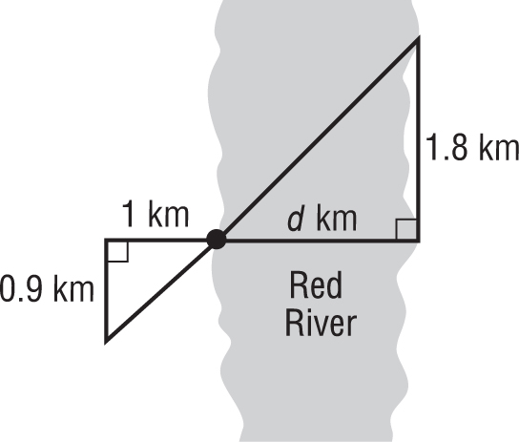
4. SURVEYING The two triangles shown in the figure are similar. Find the distance d across Red River.

